PROJECT DOCUMENTATION

1️⃣ Introduction
• Project Title:
UNESCO World Heritage 2019 Interactive Dashboard System
• Team Members:
Name | Role
Akhila Peruri | Full Stack Developer (Backend, Frontend, Database Integration, Visualization)

2️⃣ Project Overview
• Purpose
The purpose of this project is to develop a secure and interactive web-based dashboard system to analyze UNESCO World Heritage Sites data (2019). The application provides user authentication and controlled access to an embedded Tableau visualization that presents insights into global heritage distribution.
The system ensures:
- Secure login and registration
- Admin-based user management
- Interactive data visualization
- Structured presentation of heritage site insights

• Features
- User Registration
- Secure Login Authentication
- Protected Dashboard Access
- Embedded Tableau Story Visualization
- Admin Panel (User Management)
- Activate/Deactivate Users
- Responsive Bootstrap UI
- Session-Based Authentication
- Secure Password Hashing

3️⃣ Architecture
• Frontend (Bootstrap + HTML + CSS)
The frontend is developed using:
- HTML5
- Bootstrap 5
- Custom CSS styling
- Django Templates
Frontend Flow:
Home Page → Login/Register → Dashboard → Tableau Story → Insights
Key UI Components:
- Navigation Bar
- Dashboard Card Layout
- Embedded Tableau Visualization
- Admin Panel Table
- Insight Section

• Backend (Django Framework)
The backend is built using:
- Django 5.2.9
- Django Authentication System
- Django Views & URL Routing
- Template Rendering
Backend Responsibilities:
- User authentication
- Session handling
- Route protection using @login_required
- Admin authorization using is_superuser
- Rendering templates
- Database interaction

• Database (SQLite)
The default Django SQLite database is used.
User Table Structure (Django Auth Model)
Field | Type
id | Integer
username | String
email | String
password | Hashed String
is_active | Boolean
is_superuser | Boolean
Database Operations:
- Insert user (Registration)
- Authenticate user (Login)
- Update user status (Admin panel)
- Retrieve users (Admin dashboard)

4️⃣ Setup Instructions
• Prerequisites
Install the following:
- Python 3.11+
- Django
- pip
- Internet connection (for Tableau embed)

• Installation Steps
Step 1 – Clone or Create Project
django-admin startproject tableau_project
cd tableau_project
python manage.py startapp core

Step 2 – Install Django (if not installed)
pip install django

Step 3 – Configure Database
Run migrations:
python manage.py makemigrations
python manage.py migrate

Step 4 – Create Superuser
python manage.py createsuperuser

5️⃣ Folder Structure
tableau_project/
│
├── manage.py
├── db.sqlite3
│
├── tableau_project/ # Main Project Configuration
│ ├── __init__.py
│ ├── settings.py
│ ├── urls.py
│ ├── asgi.py
│ └── wsgi.py
│
├── core/ # Main Application
│ ├── __init__.py
│ ├── admin.py
│ ├── apps.py
│ ├── models.py
│ ├── views.py
│ ├── forms.py
│ ├── tests.py
│ ├── urls.py
│ └── migrations/
│ └── __init__.py
│
├── templates/ # HTML Templates
│ ├── base.html
│ ├── home.html
│ ├── login.html
│ ├── register.html
│ │
│ └── dashboard/
│ ├── dashboard_home.html
│ └── admin_panel.html

6️⃣ Running the Application
Start Server
python manage.py runserver
Application runs on:
http://127.0.0.1:8000/

7️⃣ API Documentation (Internal Routes)
URL | Method | Description
/ | GET | Home Page
/login/ | GET/POST | Login
/register/ | GET/POST | Register
/dashboard/ | GET | Protected Dashboard
/admin-panel/ | GET | Admin User Management
/logout/ | GET | Logout

8️⃣ Authentication
Authentication is handled using Django's built-in authentication system.
Process:
- User registers
- Password is hashed automatically
- User logs in
- Django creates session
- Protected routes use @login_required
- Admin panel uses user.is_superuser
Security Features:
- Password hashing
- Session-based authentication
- Route protection
- Superuser-based authorization

9️⃣ User Interface
The UI includes:
- Blue gradient background
- Centered project title
- Embedded Tableau story
- Insight section below visualization
- Admin panel with user table
Admin Table Columns:
- S.No
- Username
- Email
- Password (hashed)
- Status
- Activate/Deactivate button

🔟 Testing
Testing Strategy:
- Manual form validation testing
- Authentication testing
- Role-based access testing
- Tableau embed verification
- Admin panel toggle testing
Tools Used:
- Django server
- Browser testing
- Developer console

1️⃣1️⃣ Screenshots / Demo
Include screenshots of:
- Home Page


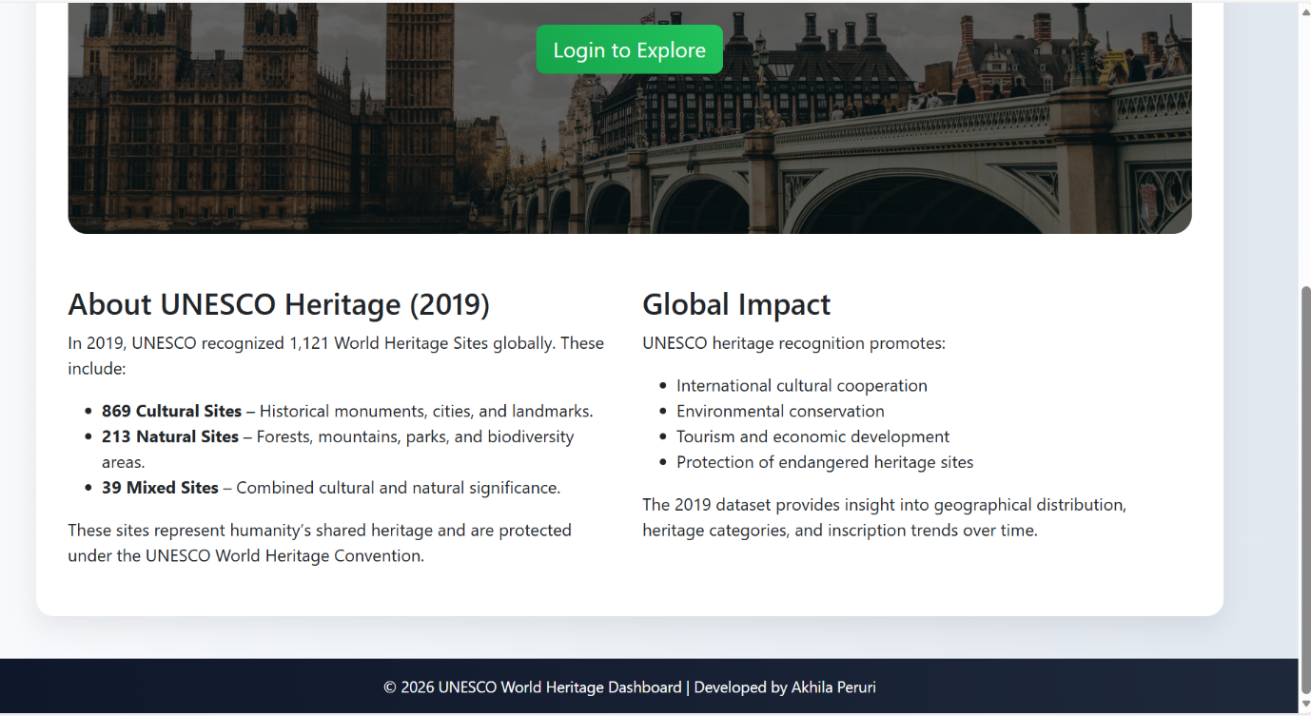
- Login Page
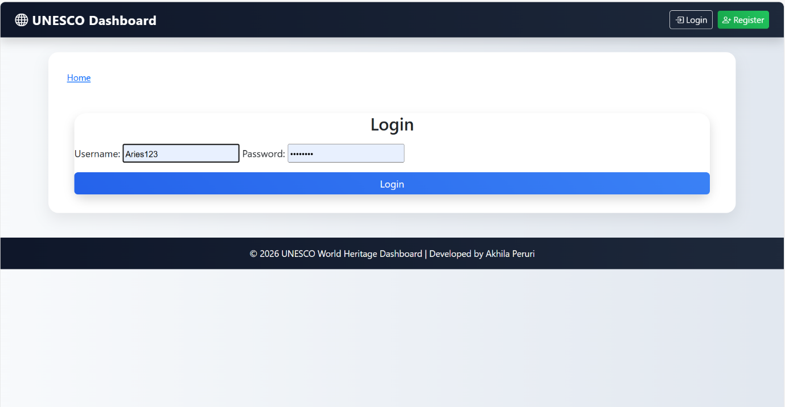
- Register Page
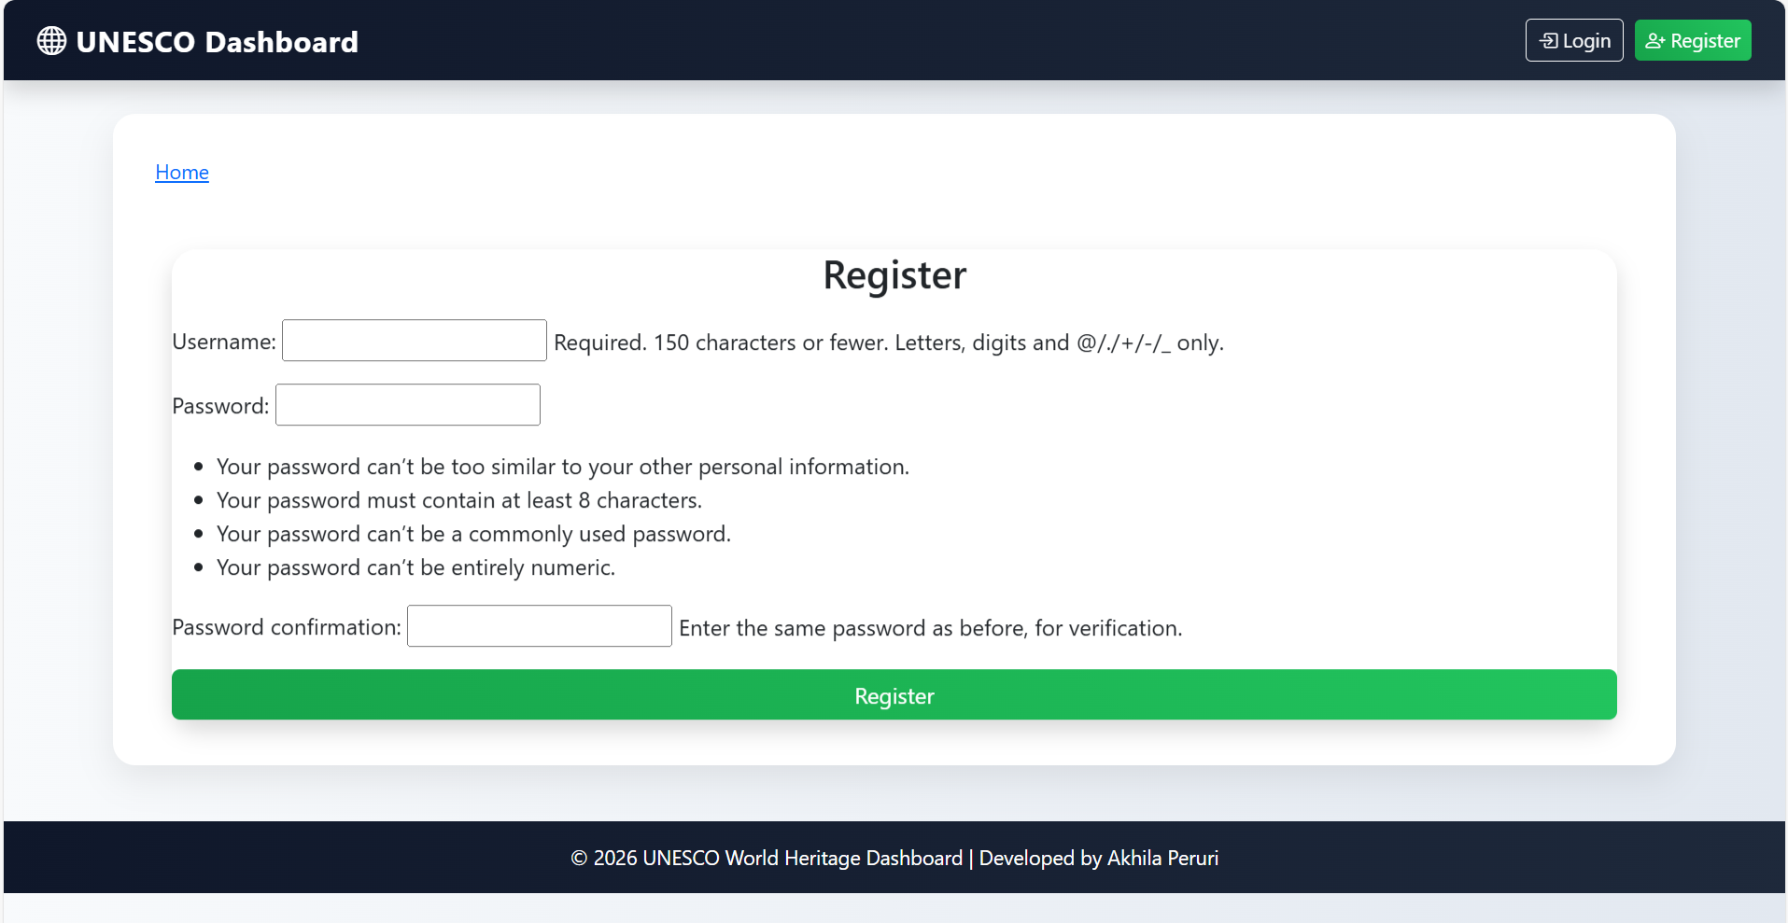
- Dashboard Page
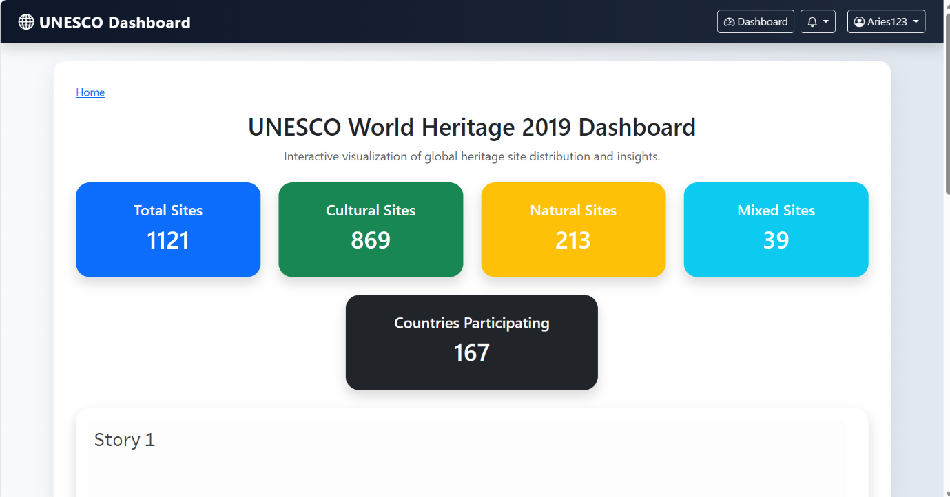
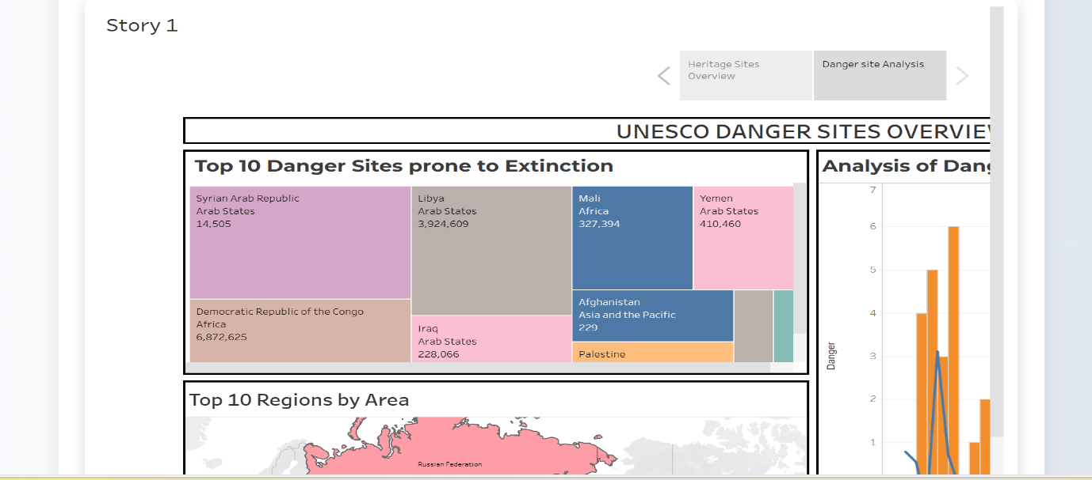
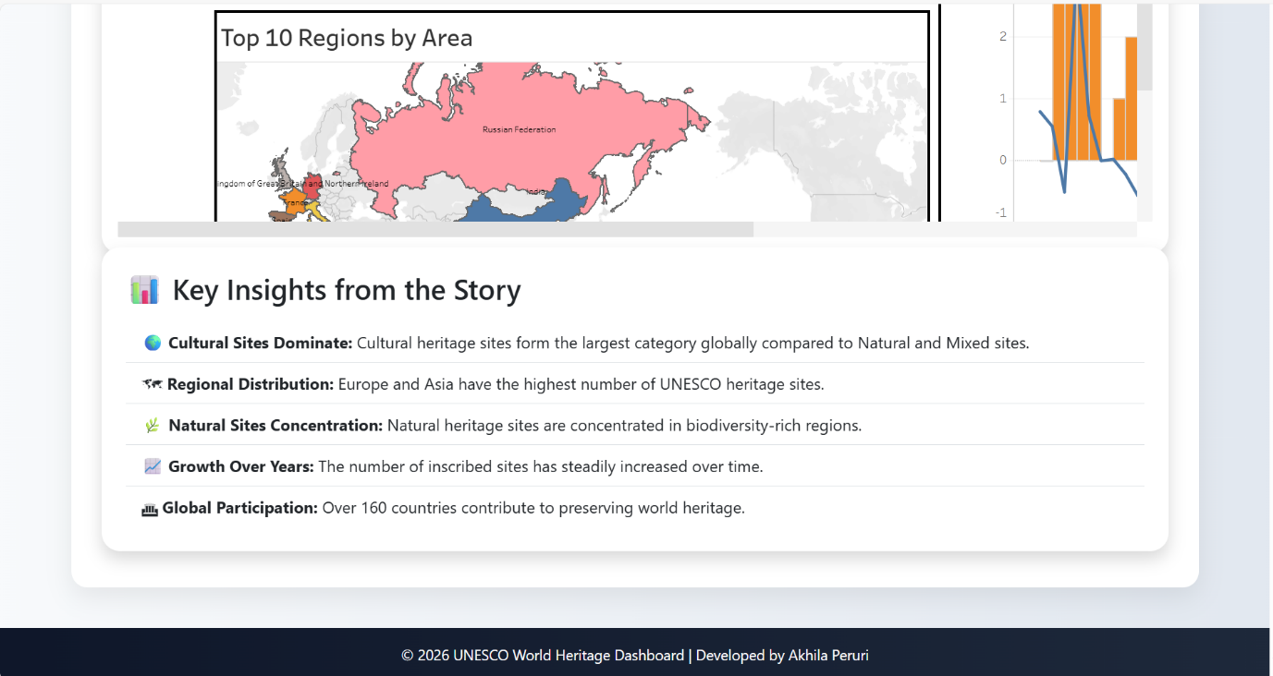

1️⃣2️⃣ Known Issues
- Tableau embedding may fail if workbook is private
- No password reset functionality
- No pagination in admin panel
- SQLite not scalable for large systems

1️⃣3️⃣ Future Enhancements
- Add password reset feature
- Add search & filter in admin panel
- Add pagination
- Add role-based dashboard
- Deploy to cloud (Render / AWS)
- Replace SQLite with PostgreSQL
- Add analytics summary cards
- Improve UI with animations

Conclusion
The UNESCO World Heritage Dashboard system provides a secure, structured, and interactive platform for exploring global heritage site data. The project demonstrates skills in backend development (Django), frontend UI design (Bootstrap), authentication handling, database management, and data visualization integration using Tableau.

